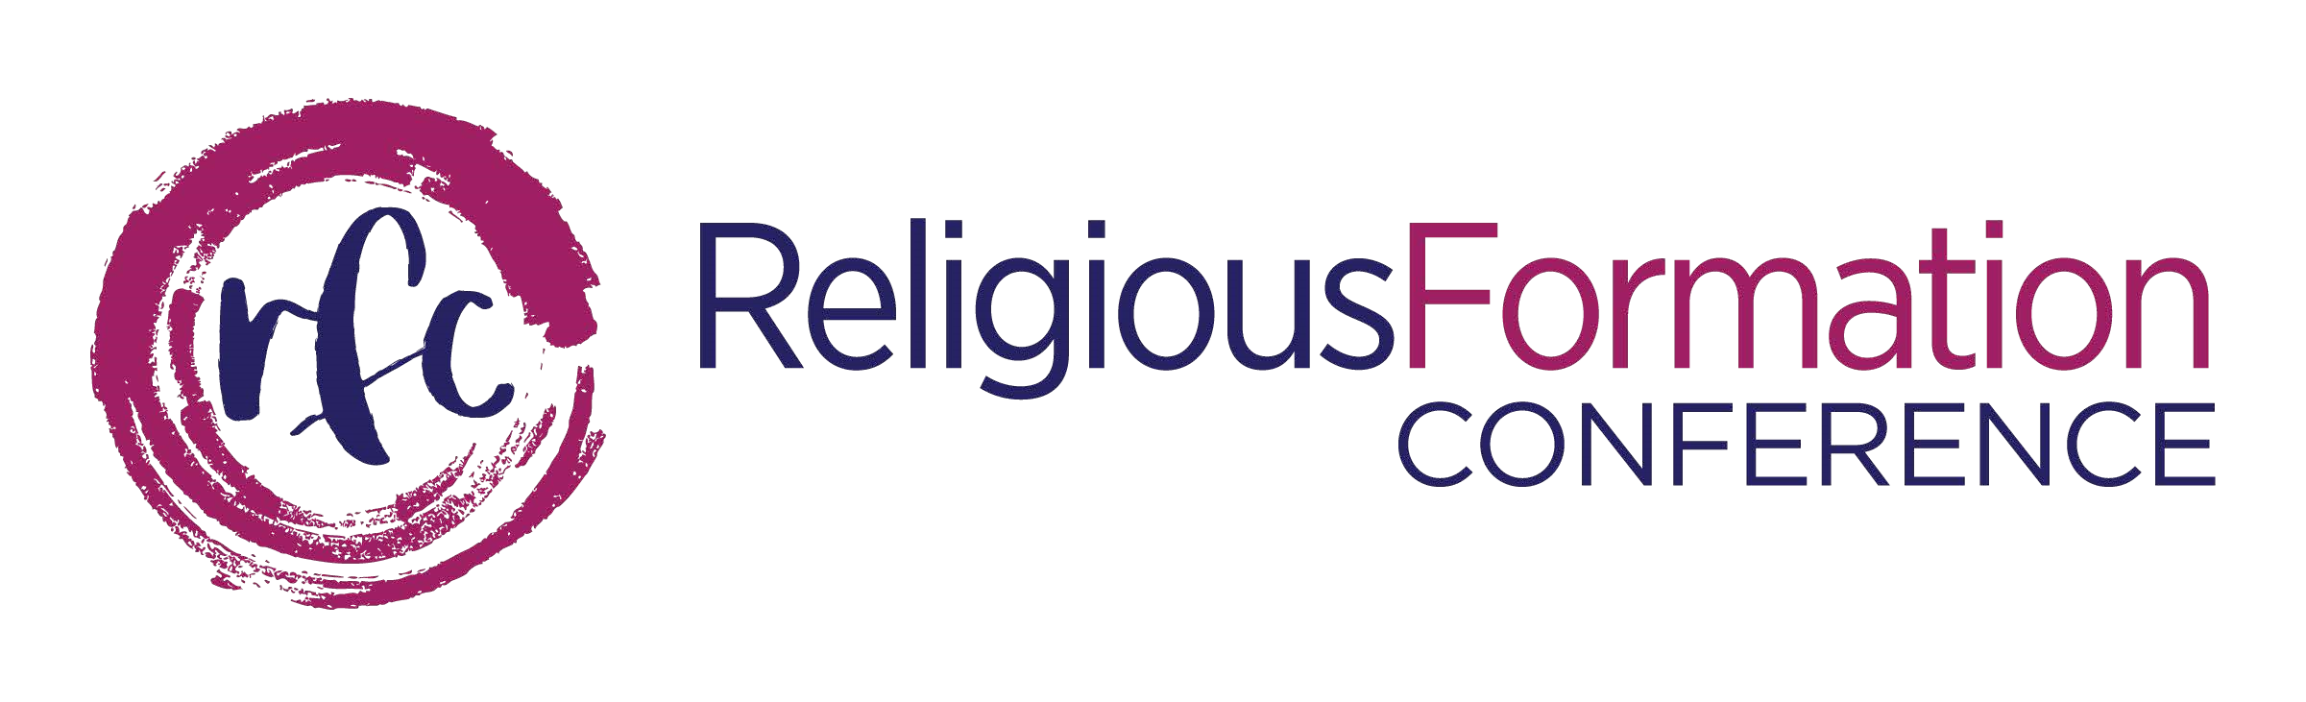
PRESENTERS
Maco Cassetta, CND & Paul English, CSB
Oct 9-11; Oct 9-12; or Oct 11-12
Catholic Theological Union, Chicago, IL

- The Orientation to Formation Workshop, has historically been a Friday evening – Sunday noon, weekend event. The event has been extended one day, from Sunday noon to Monday noon to include time to address contemporary issues particular to those in positions of leadership with oversight responsibilities for initial and ongoing formation in relationship with ministers of formation.
All sessions are open to all who are interested in engaging the topics presented.

PLEASE read before you complete your registration form:
- Three (3) different registration options are available – Oct 9-11; Oct 9-12; or Oct 11-12.
Please review each option, select the dates of your choice, and register for only one option.
Complete registration form and return with payment to the address provided on page three. Please keep a copy for your records. Thank you!

Participant Name: _______________________________________________________
Religious Institute and Initials: _____________________________________________
Country:________________________________________
Address:________________________________________________________________
City/State/Zip:___________________________________________________________

Email: ____________________________________________________

Phones (H):_____________________ (C)_____________________(W)___________________

Personal Address: _____________________________________________________________

Personal City/State/Zip: ________________________________________________________
Special Needs (room accommodations, meals, etc): _________________________________

Continue…
Register for October 9 – 11, 2020 Begin Friday evening & end Sunday noon
- SIGN with Initials here to register for Oct 9-11: ____________
I am: _____ in Leadership ____a Minister of Formation a Formation Community Member
______ a Formation Mentor ______ a Vocation Director
Fees (includes tuition):
Member (2 overnights and 6 meals): $550 ________ Non-Member: $650
Commuter w/all 6 meals: $400 _________Non-Member: $500.
Late fee after September 9, 2020 add $25.00 to each category above.

Register for October 9 – 12, 2020 Begin Friday evening & end Monday at 12:30 pm

- SIGN Initials here to register for Oct 9-12: ____________
I am: _____ in Leadership ____a Minister of Formation a Formation Community Member
______ a Formation Mentor ______ a Vocation Director
Fees (includes tuition):
Member (3 overnights and 9 meals): $650 ________ Non-Member: $750
Commuter w/all 9 meals: $450 _________Non-Member: $550
Late fee after September 9, 2020 add $25.00 to each category above.

Register for October 11-12, 2020 Begin Sunday noon & end Monday at 12:30 pm

- SIGN Initials here to register for Oct 11-12: ____________
I am: _____ in Leadership ____a Minister of Formation a Formation Community Member
______ a Formation Mentor ______ a Vocation Director Continue
Fees (includes tuition):
Member (1 overnight and 3 meals): $200 ________ Non-Member: $275
Commuter w/all 3 meals: $125 _________Non-Member: $200
Late fee after September 9, 2020 add $25.00 to each category above.

Registration Form and payment of workshop fee:
- Complete fee is due with registration, by check or money order, in US dollars, drawn on a US bank and made payable to the Religious Formation Conference. Please mail everything to the address below, attn.: Orientation to Formation. Your cancelled check is your receipt. You will receive confirmation once your registration has been received.
- To pay by credit card go to https://www.relforcon.org/programs/orientation-formation
- Program scholarship funds are available to RFC member congregations/provinces
- For program scholarship information go to:
https://www.relforcon.org/scholarship-funds

Cancellation fee is $75.00 per registrant. Please request refund in writing or by email.
If you have any questions please contact Connie Schoen, OP, RFC Program Director, at cschoen@relforcon.org

Religious Formation Conference
5401 S. Cornell Street, suite #304
Chicago, IL 60615
www.relforcon.org

