RFC Hudson Valley Area Presents…

The Psycho-Social and Spiritual Dimensions of the Enneagram:
A System to Self Discovery
with Sisters Pat Smith, SSJ and Maco Cassetta, CND

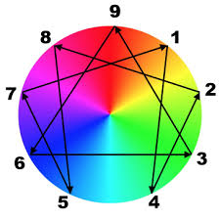

Arrival: Thursday, February 13, 2020 Noon (Lunch included)
Departure: Monday, February 17, 2020 Noon
Where:
Maryknoll Sisters
10 Pinesbridge Road
Ossining, NY 10562
For:
Sisters and Brothers in Initial Formation
Sisters and Brothers living in Formation Communities
Sisters and Brothers on a quest of Self-Discovery through the Enneagram
Cost:
Hudson Valley Members with overnight accommodations $400, commuting $250
Non-member with overnight accommodations $420, commuting $270
Register by:
January 25, 2020
___________________________________________________________________

How to Register: Detach below
Make checks payable to: RFC Region 2
Names of Participants:
1.
2.
3.
4.
Send to:
Pat Niblock, OP
Dominican Convent
175 Route 340
Sparkill, NY 10976
pat.niblock@sparkill.org

